Practical 22: Android Studio

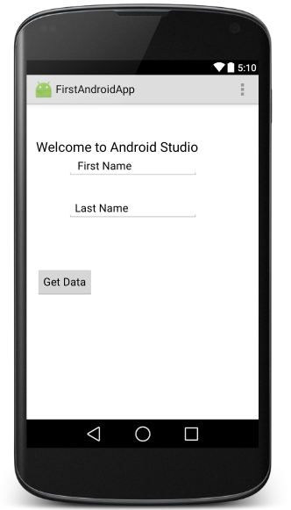
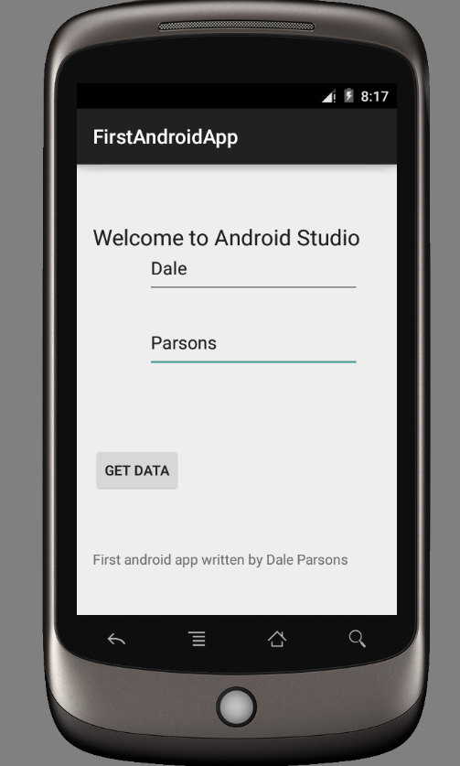
Exercise 1: Follow along in class

Exercise 2: Check your code with sample
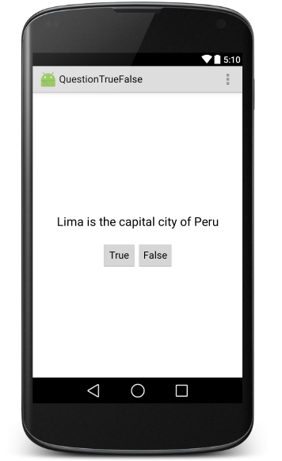

For the layout xml file
Change your layout to a LinearLayout with a vertical orientation. Make the width and height match the parent container and center its contents on the screen; this attribute is called gravity.
Drag on a large text view, set its padding to 24dp.
Drag on a horizontal LinearLayout and place two buttons inside .

In the MainActivity.java file
To make the button work:
Make the class implement View.OnClickListener
Give each button the setOnClickListener method
Code the onClick(View v) method

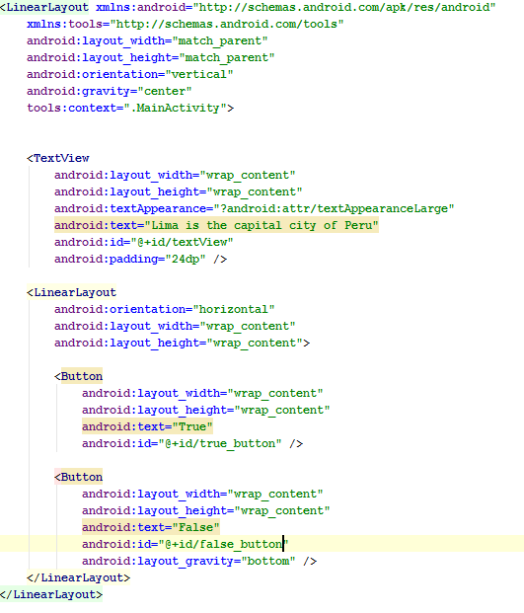

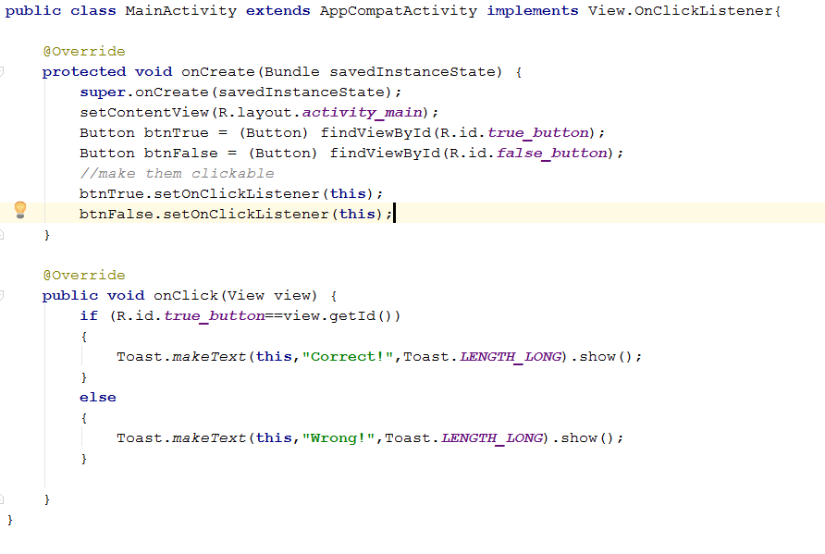

Resources
Using constraint layout https://youtu.be/4N4bCdyGcUc and

https://youtu.be/2FOFd77o7eg

https://www.raywenderlich.com/120508/beginning-android-development-tutorial-android-studio

http://guides.codepath.com/android#views-and-layouts

http://chiuki.github.io/android-layout-101

Lynda.op.ac.nz Android App Development Essential Training

http://www.lynda.com/Android-tutorials/Using-LinearLayout-containers/442863/456767-4.html
http://www.lynda.com/Android-tutorials/Using-RelativeLayout-containers/442863/456768-4.html

http://www.lynda.com/Android-tutorials/Display-collect-text-values/442863/456770-4.html

